MANDATORY DISCLOSURE

  - Name of the Institution J.K.K.NATARAJA COLLEGE OF ARTS
AND SCIENCE
NH-544, Natarajapuram(Salem To Coimbatore),
Komarapalayam - 638 183, Namakkal – District, Tamil Nadu,
Phone no: 9965363999 Mail ID: arts@jkkn.org
  - Name and Address of the Trust J.K.K. Rangammal Charitable Trust
230,Salem Main Road, Komarapalayam- 638183
Telephone : 04288-266037
Phone no: 98941 16664 Mail ID: trust@jkkn.org
  - Name and address of the Principal Dr.C.Seeranganayaki, M.Com., M.Phil.,
PGDCA., Ph.D.,
Principal (i/c),
J.K.K.Nataraja College of Arts and Science, NH-544, Natarajapuram(Salem To Coimbatore),
Komarapalayam - 638 183, Namakkal - District., Tamil Nadu.
Phone No: 9443929596
Mail ID: seeranganayaki.c@jkkn.ac.in
  - Name of the Affiliating University Periyar University, Salem

  - NAAC Accreditation Status

NAAC Accreditation Status
1 | Accredited | B Grade (CGPA : 2.37)
2 | Applied for Accreditation | -
 | - Applied but Visit not happened | -
 | - Visit happened but result awaited | -
3 | Not Applied | -

  - Governance
Members of the Board
S.No. | Name | Designation
1 | Mrs.N.Sendamaraai | Secretary
2 | Mr.S.Ommsharravana, | Member
3 | Mrs.K.Savithiri | Member
4 | Dr.(Mrs).C.Seeranganayaki, Principal(i/c)  J.K.K.Nataraja College of Arts and Science, | Member

NH-544, Natarajapuram(Salem To Coimbatore),
Komarapalayam - 638 183, Namakkal - District.,
Tamil Nadu.
5 | Dr.K.T.Tamizharasu, Principal,  J.K.K.Nattraja College of Engineering & Technology, Komarapalayam | Member
6 | Dr.R.Sampathkumar, Principal,  J.K.K.Nattraja College of Pharmacy, Komarapalayam | Member
7 | Mr.S.K.P.Murugean  Industrialist | Member
8 | Mr.M.Sundaresan,  Regional Officer & Assistant Director,  Southern Regional Office, AICTE, Shastri Bhawan, 26,Haddows Road,  Nungambakkam,Chennai-600006 | Member - AICTE  Representative
9 | Dr.T.Periyasamy, Professor & Head, Dept. of Tamil,  Periyar University, Salem. | Member - University Representative
10 | Dr.Ramalakshmi  Regional Joint Director of Collegiate Education, Dharmapuri Region, Dharmapuri-636 705. | Member - State Government Representative
11 | Mrs. S. Malathi,  Associate Professor and Head, Department of Chemistry | Member – Faculty
12 | Mrs. S. Mangayarkarasi,  Associate Professor, Department of Chemistry | Member – Faculty
Frequent of the Board Meeting

Members of Academic Advisory Body
1 | Dr.C.Seeranganayaki | Chairman, Academic Council & Principal (i/c)
2 | Dr. S. Uma | HOD / Tamil
3 | Dr.K.Radhai | HOD / English
4 | Mrs. R. Kalpana Devi priya | HOD / History
5 | Dr. P. Vennila | History
5 | Mrs. S. Bharathi | HOD / Geography
6 | Dr. B. Suresh | HOD / Economics
7 | Dr. R. Rajanarthini | HOD / Physics
8 | Mrs. S. Malathi | HOD / Chemistry
9 | Mrs. S. Mangayarkarasi | Chemistry
10 | Dr. S. Umavathi | HOD / Zoology
11 | Dr. Y. Thangam | Zoology
12 | Mr. N. Udhaya Kumar | HOD / Botany
13 | Mrs. T.Santhi | HOD / Mathematics
14 | Dr. K.P. Sivagami | HOD / Computer Science
15 | Mrs. C. Seeranganayaki | HOD / Commerce
16 | Mrs. S.Gokila | Commerce
17 | Dr. S. Sasikala | Library
18 | Dr. V. Anitha | Physical Education

Organizational chart
TRUSTEES
OFFICE
PRINCIPAL
Students

Associate Professors Assistant Professor
HOD

Lab Assistants & Attenders
Library

Student Feedback on Faculty Performance/ Institutional Governance: Available in the Website Grievance Redressal Mechanism for Faculty, staff and students: Updated in Website Establishment of Anti Ragging Committee : Updated in Website
Establishment of Online Grievance Redressal Mechanism: Updated in Website

Establishment of Grievance Redressal Committee in the Institution and appointment of OOBUDSMAN by the University: Updated in Website

Establishment of Internal Compliant Committee (ICC): Updated in Website

Establishment of Committee for SC / ST: Updated in Website

Internal Quality Assurance Cell: Updated in Website

  - Programme

Name of Programmes approved by AICTE

S  . N  o  . | Program | Sh ift | Level | Course | Affiliat ing Body (Univ/ Body) | Intake Approv ed for  2022-  2023 | NRI  Approv al Status | PIO/FN  / Gulf quota/ OCI/  Approv al Status
1 | MCA | 1st | POST GRAD UATE | MASTER OF COMPUTER APPLICATIO NS | Periyar Univer sity | 15 | NA | NA

Name of the Programme |  | MCA
Programme introduced in the Year |  | 1987-1988
Sanctioned Intake |  | 15
Year of approval by the AICTE council |  | 2018-2019
Students  Achievements | University Ranks
2008-2011 - M. Booma Niranjana – Fifth
2009-2012 - T. Cinas Parveen – First
2010-2013 - K. Yugapriya – Sixth
2010-2013 - K. Geetha – Tenth
2014-2017 – A. Abinaya – Third

Professional Activities | - National level seminar on Biometric Authentication 02-02-2018  - One day workshop on Practical aspects of Mobile App Development Tools on 19- 09-2018  - One day webinar on Digital Tools for E-Content Development on 09-05-2020  - Five days AICTE - ATAL online FDP on Recent Trends in Artificial Neural Networks from 21.09.2021 to 25.09.2021
Professional Society Memberships | - Indian Society of Remote Sensing  - Computer Society of India  - Indian Society for Technical Education

  - Faculty

MCA Faculty members

Permanent Faculty

Permanent Faculty: Student Ratio = 1:5

Number of Faculty employed and left during the last three years: 4

Permanent Faculty details:

S. N  o | Faculty Name | Designation | Appointment Date
1 | Dr. K. P. SIVAGAMI | Associate Professor & Head . | 14.09.1988
2 | Ms. A. GEETHA | Associate Professor | 13.09.1989
3 | Dr.S. ARANGANAYAGI | Associate Professor | 10.02.1992
4 | Dr. E. HARIPRIYA | Assistant Professor | 06.07.2015
5 | Mrs. K. VEENA | Assistant Professor | 06.07.2015
6 | Dr. V. SASIREKHA | Assistant Professor | 06.07.2015

  - Profile of Principal : Updated in the Website Faculty Profile : Updated in the Website
  - State Govt. Scholarship provided to the students

  - Admission

Number of seats sanctioned with the year of approval: 15

Number of Students admitted under various categories each year in the last three years:
2022 - 2023
I MCA - 12

2021 - 2022
- MCA - 15

2020 – 2021 I MCA - 7

Number of applications received during last two years for admission under Management Quota and number admitted:

I MCA
2022 – 2023
Applications Received:
Number of Students Admitted:12
2021 – 2022
Applications Received: 17 Number of Students Admitted: 15

  - Admission Procedure:

    - TANCET Exam conducted by Anna University, Chennai – 600 025. http://tancet.annauniv.edu/tancet/
    - Tamil Nādu Self Financing College of Arts &Science Consortium Exam conducted by TNSF Consortium

Consortium of Self-Financing Professional, Arts and Science Colleges in Tamil Nādu,
AF 57, 11th MAIN ROAD, ANNA NAGAR WEST,
Chennai - 600 040.
P: +91 (44) 48647444
Email : consortium004@gmail.com
Website :http://www.tnsfconsortium.org

  - 1. Criteria and Weightages for Admission:

Merely Appeared for TANCET / Consortium exam is the minimum criteria for admission into MCA Course.

  - Information of Infrastructure and other resources available: Photos Attached at the end of the document

  - Library:

Number of Library Books: 2122

Journal List
National Journals
S.NO | Title of The Journals
1 | The IUP Journal of Information Technology
2 | The IUP Journal of Computer Science
3 | Indian Journal of Computer Science
4 | The Management Accountant
5 | Journal of Accounting and Finance
6 | Indian Historical Review
7 | Indian Historical Studies
8 | Current Science
9 | Indian Journal of Chemistry and Application
10 | Indian Journal of Chemical Technology
National Journals (E-Journals)
S.No | Title of The Journals
1 | IITM Journal of Management and IT
2 | Innovation in IT
3 | Journal of Information Management
4 | Journal of Innovation in Computer Science and Engineering
5 | Mangalmay Journal of Management & Technology
6 | Research Journal of Engineering and Technology
7 | Research Journal of Science and Technology
8 | Indian Explorer of Social Sciences & Humanities
9 | Indian Journal of Economics and Development
10 | Indian Journal of Gerontology
11 | Indian Journal of Human Relations
12 | Journal of Global Communication
13 | Journal of Politics and Governance
14 | Research Journal of Humanities and Social Sciences

International Journals (E-Journals)
1 | International Journal in IT & Engineering
2 | International Journal of Advanced Research in IT and Engineering
3 | International Journal of Applied Research on Information Technology and Computing
4 | International Journal of Bioinformatics and Biological Science
5 | International Journal of Data Mining And Emerging Technologies
6 | International Journal of Information Science and Computing
7 | International Journal of Management IT and Engineering
8 | International Journal of Scientific Research in Network Security and Communication
9 | International Journal of Technology
10 | JIMS8I â€“ International Journal of Information Communication and Computing Technology
11 | Globus - An International Journal of Management and IT
12 | Combinatorics, Probability and Computing
13 | Data-Centric Engineering
14 | Design Science
15 | Environmental Data Science
16 | Journal of Functional Programming
17 | The Knowledge Engineering Review
18 | Mathematical Structures in Computer Science
19 | Natural Language Engineering
20 | NWS Network Science
21 | Probability in the Engineering and Informational Sciences
22 | Robotica
23 | International Journal in Management & Social Science
24 | International Journal of Advanced Research in Management and Social Sciences
25 | International Journal of Research in Social Sciences
26 | International Journal Of Resilience In Fire Safety & Disasters
27 | International Journal of Reviews and Research in Social Sciences
28 | International Journal of Social and Economic Research
29 | International Journal Of Social Sciences
30 | International Journal of Sociology, Social Anthropology and Social Policy

E – Library facilities : Available

National Digital Library (NDL) subscription details : N List

  - Curricula and Syllabi : https://www.periyaruniversity.ac.in/Documents/2021/syllabus/2021/Affiliated/pg/MCA.pdf

  - List of Research Projects:

Name of the Principal  Investigator | Designation | Duration  of project | Name of the  research project | Amount /  Fund received | Year of  sanction
Dr.E.HARIPRIYA | Assistant professor of Computer Science | 2 Years | Minor Research Project-Effective Communication  in Delay Tolerant  Networks | Rs. 60,000 | 2015  (Completed)
K.VEENA | Assistant professor of Computer Science | 2 Years | Minor Research Project - The News Item Extraction  and classification  System | Rs. 60,000 | 2015  (Completed)
Dr.V.SASIREKHA | Assistant professor of Computer Science | 2 Years | Minor Research Project-Vertical Handoff Decision for seamless mobility in Heterogeneous  Wireless Networks | Rs.2,20,000 | 2017  (Completed)

  - LoA and EoA till the current Academic Year : Updated in Website

Letter Of Approval 2018-19

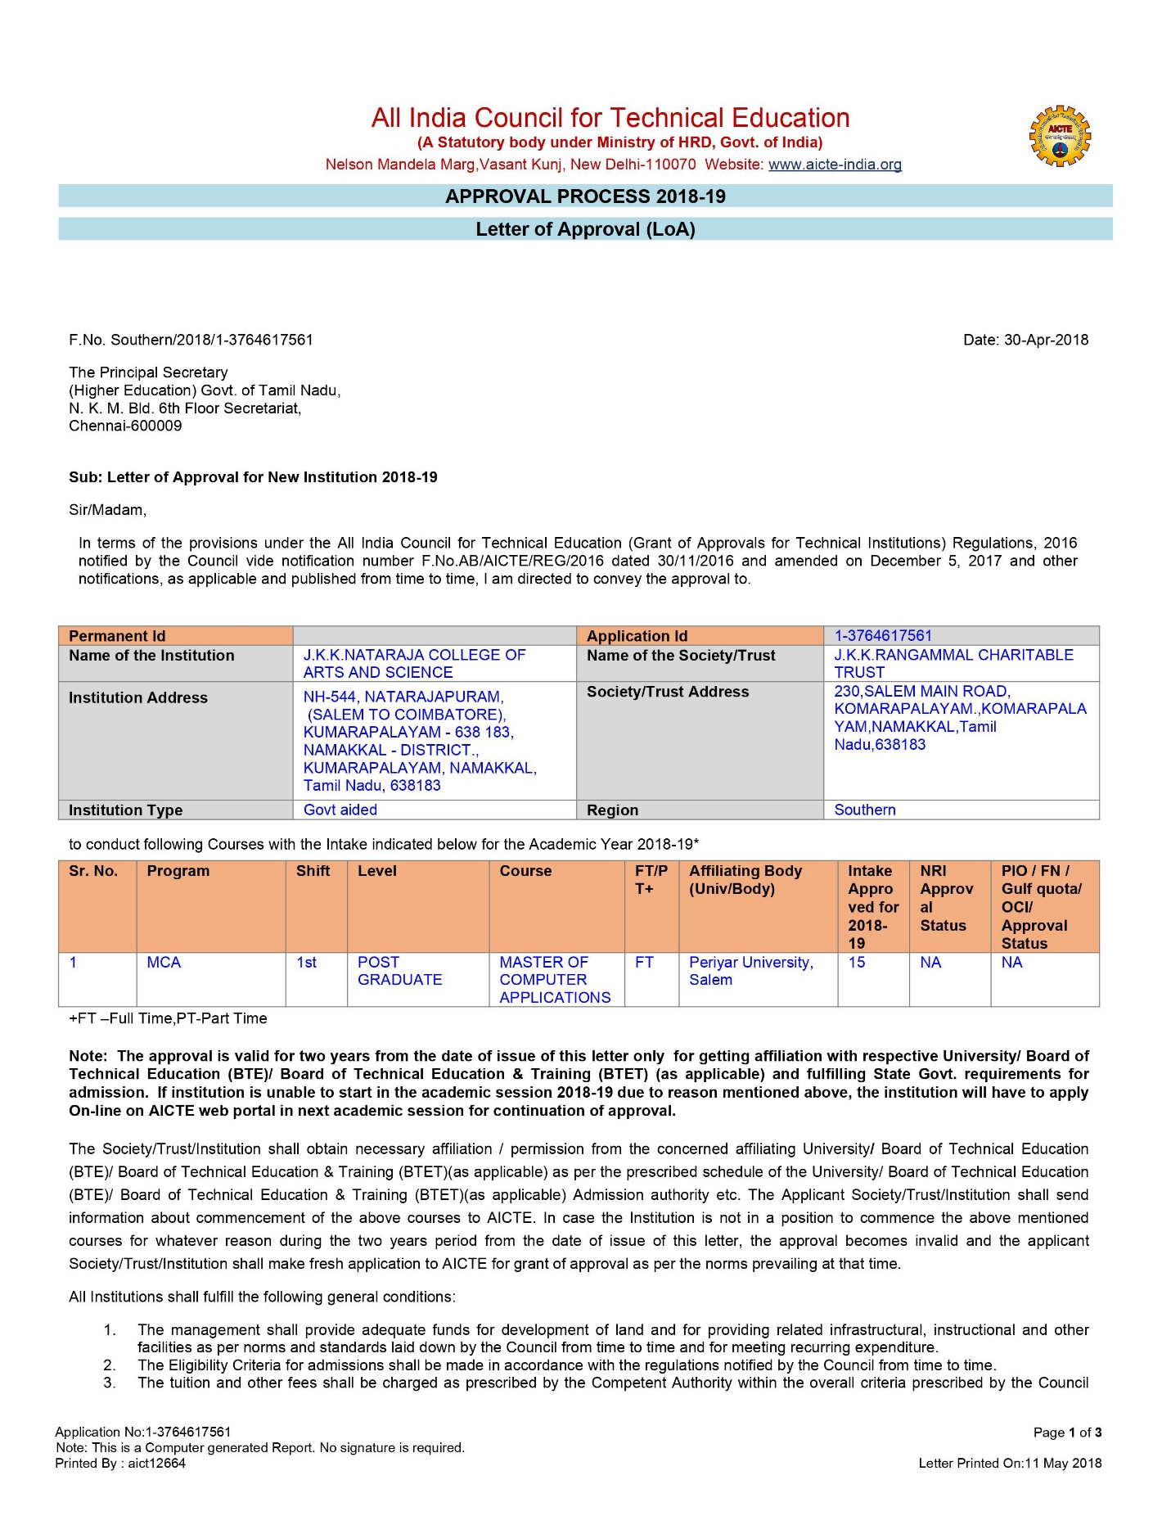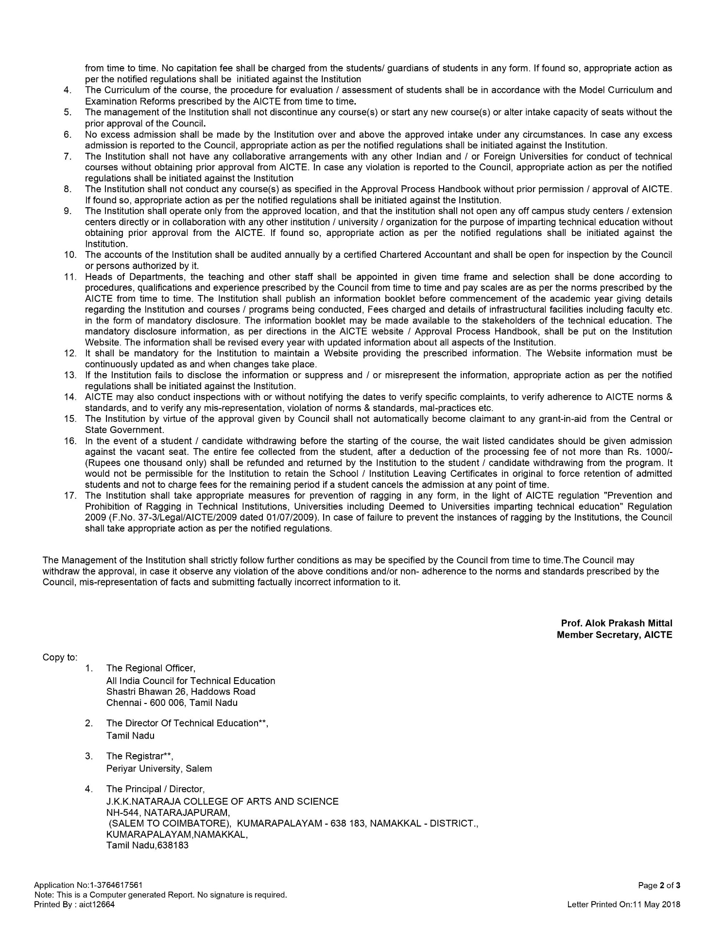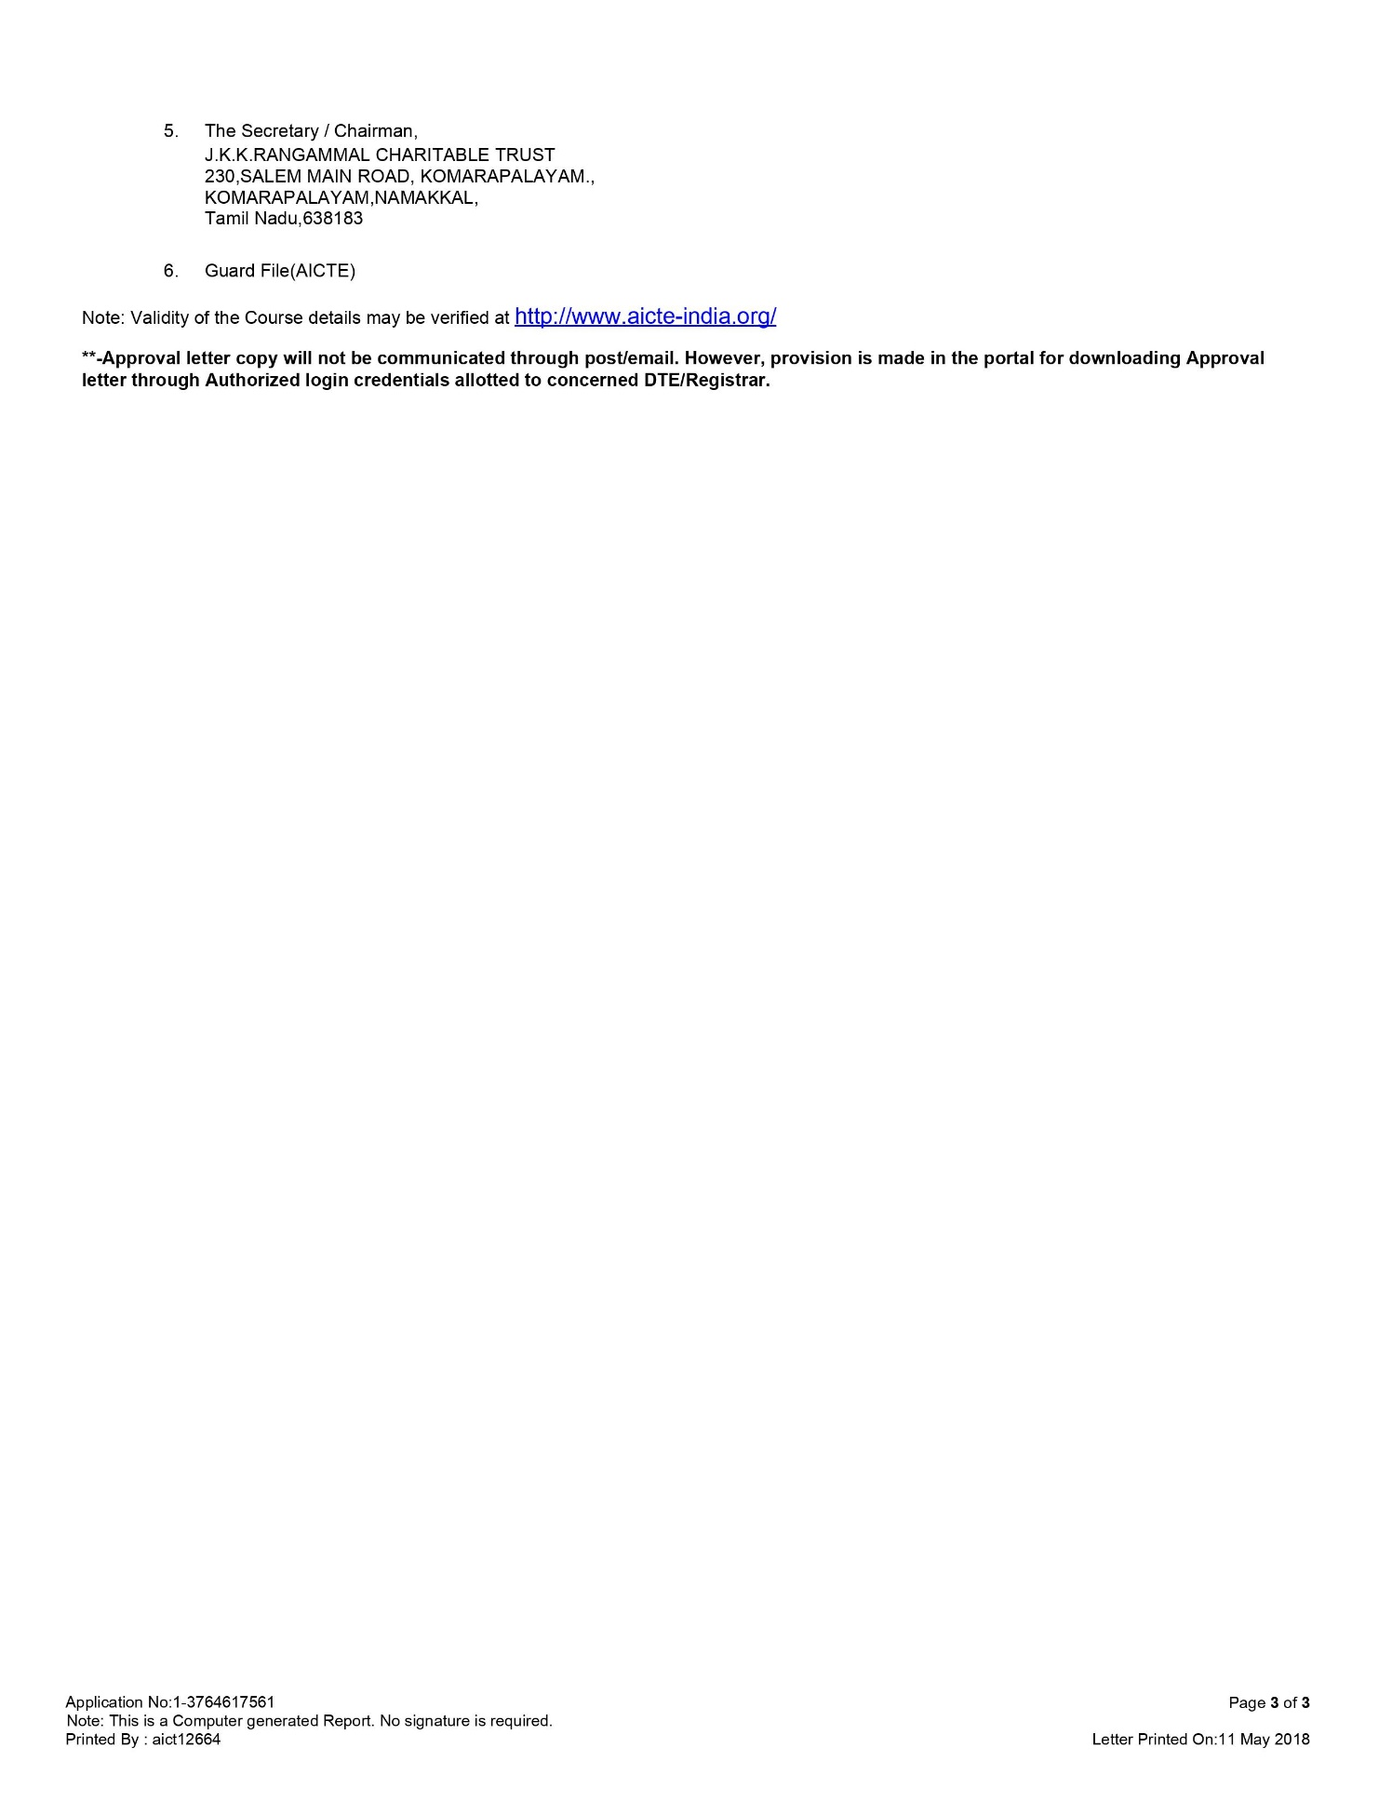

EOA_Report 2019-20

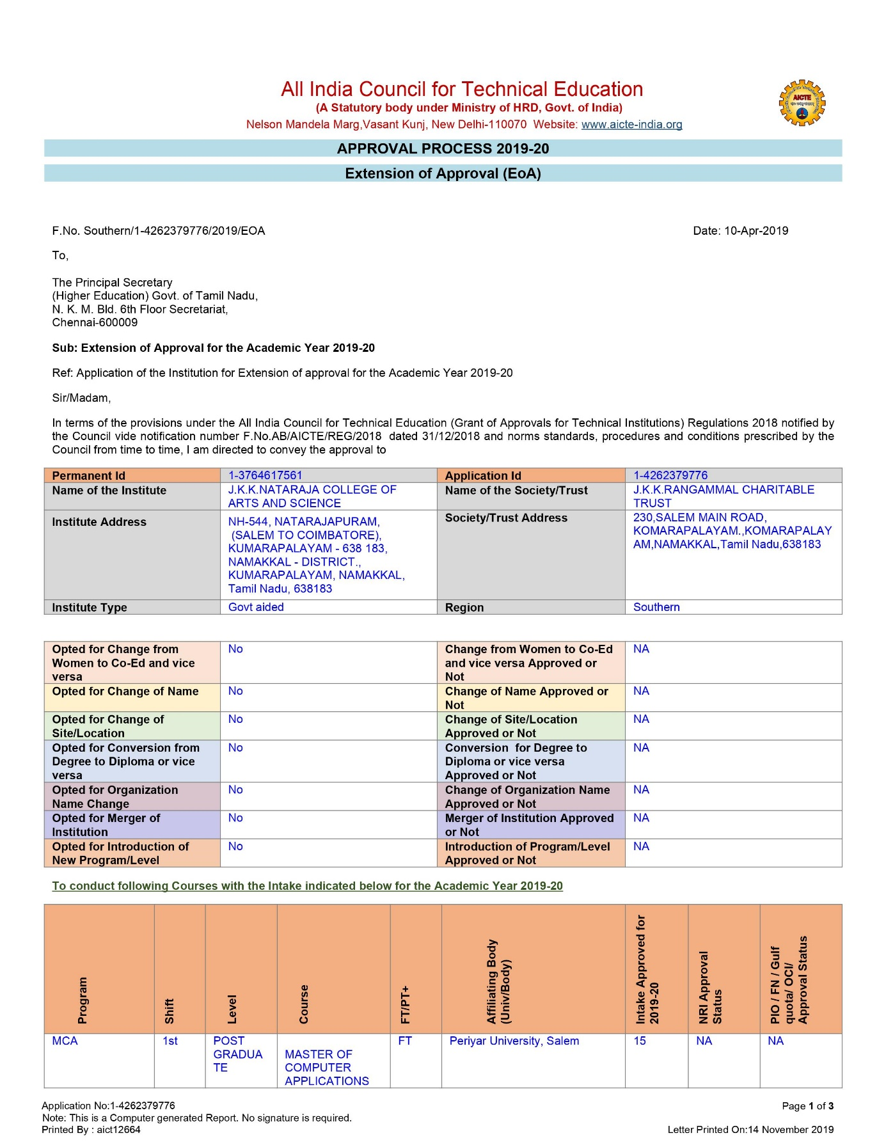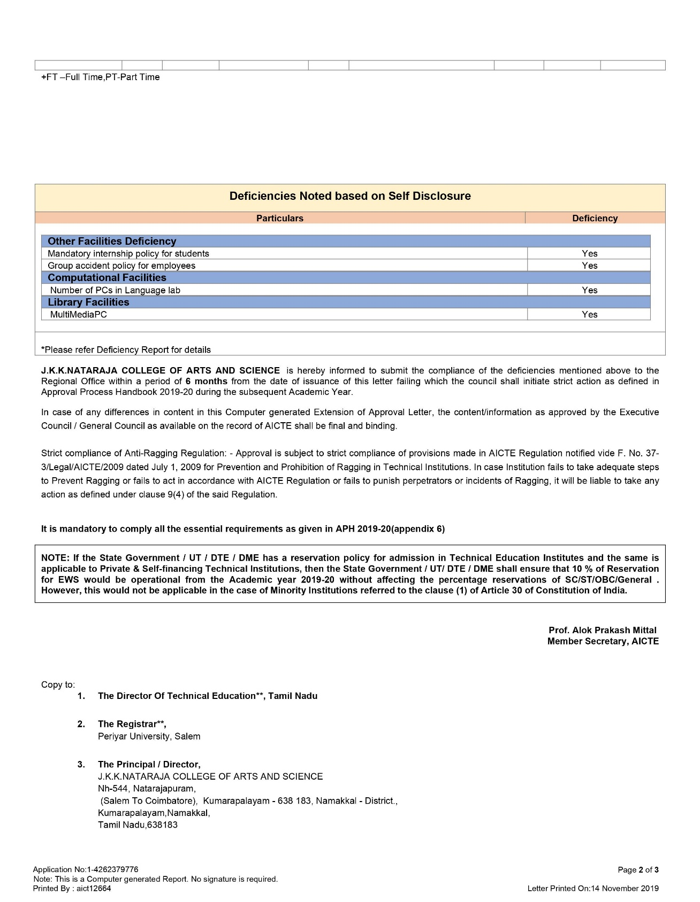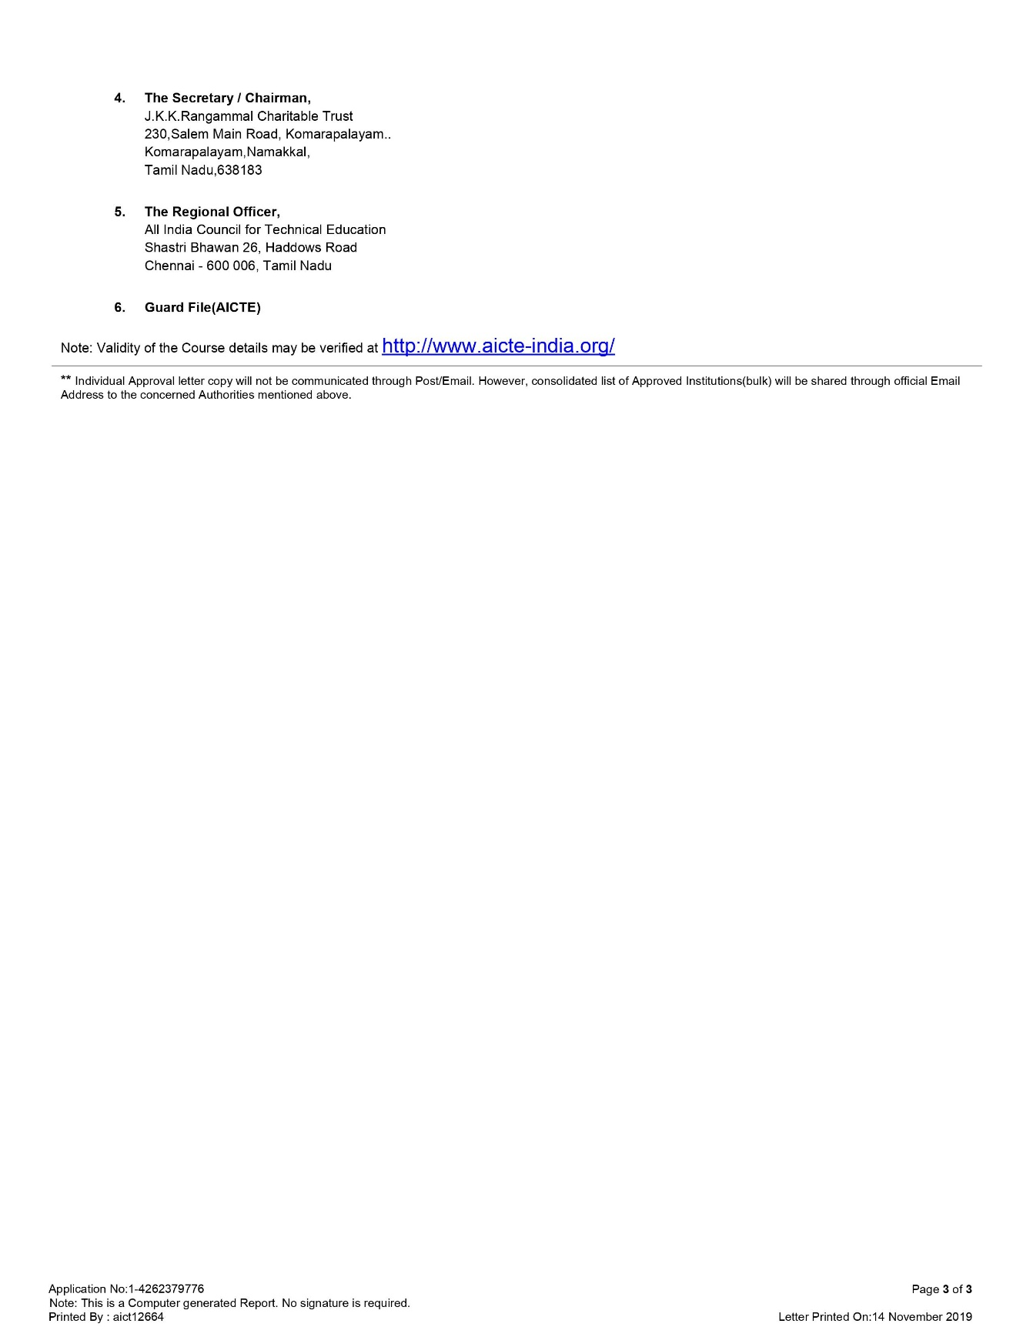

EOA_Report_2020-21

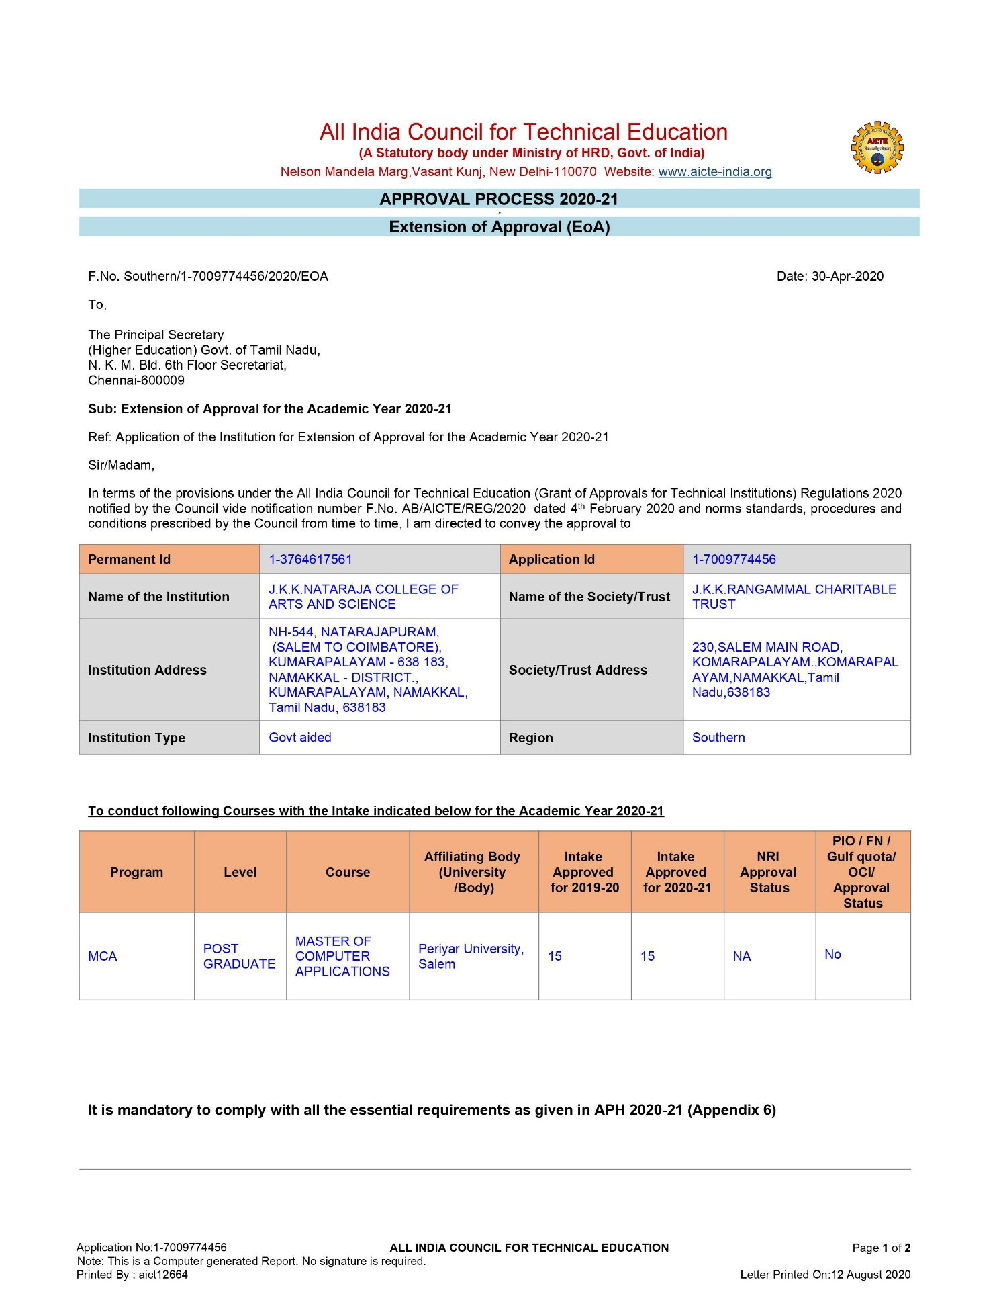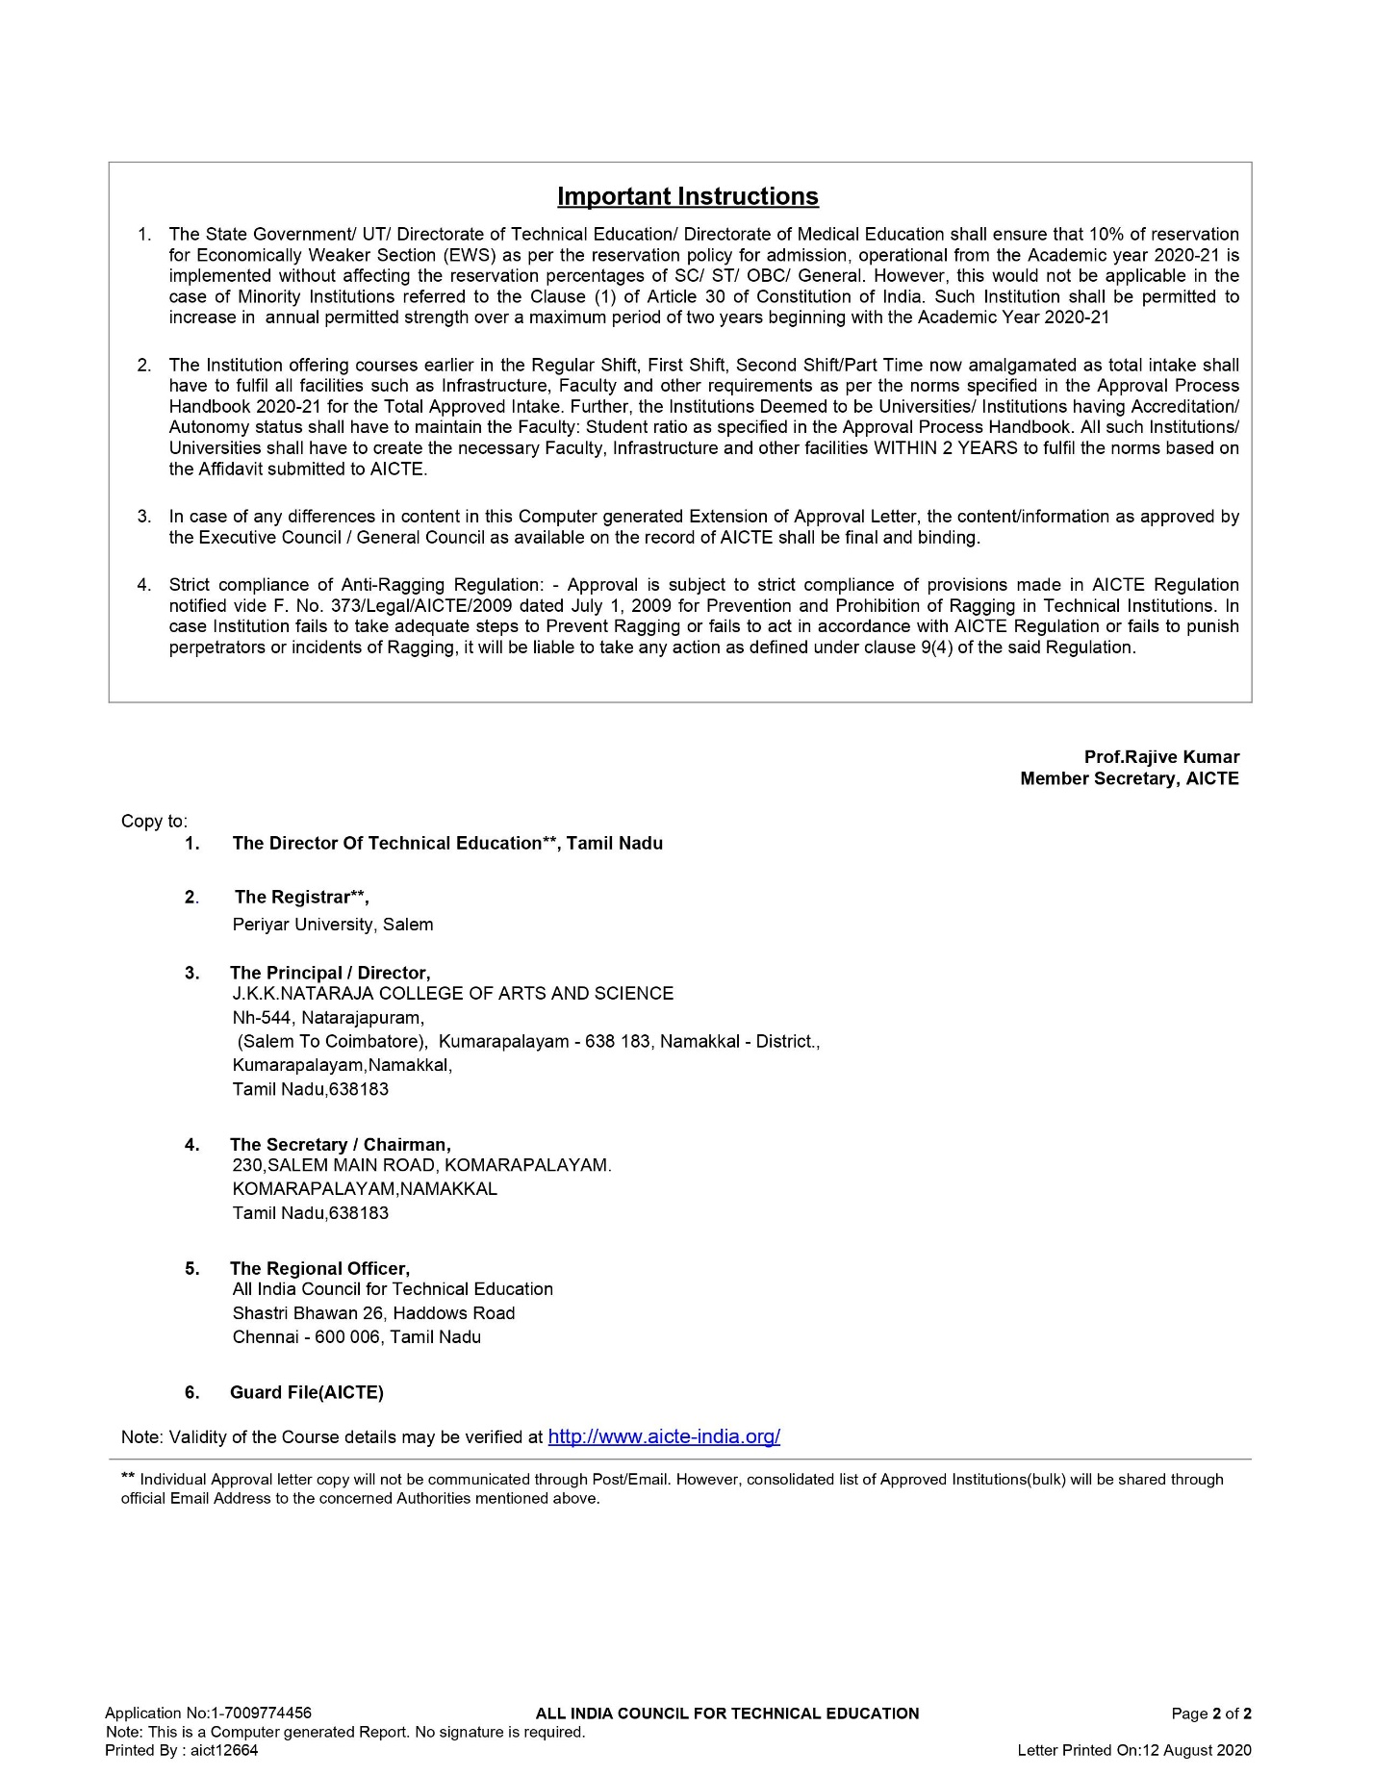

EOA_Report 2021-2022

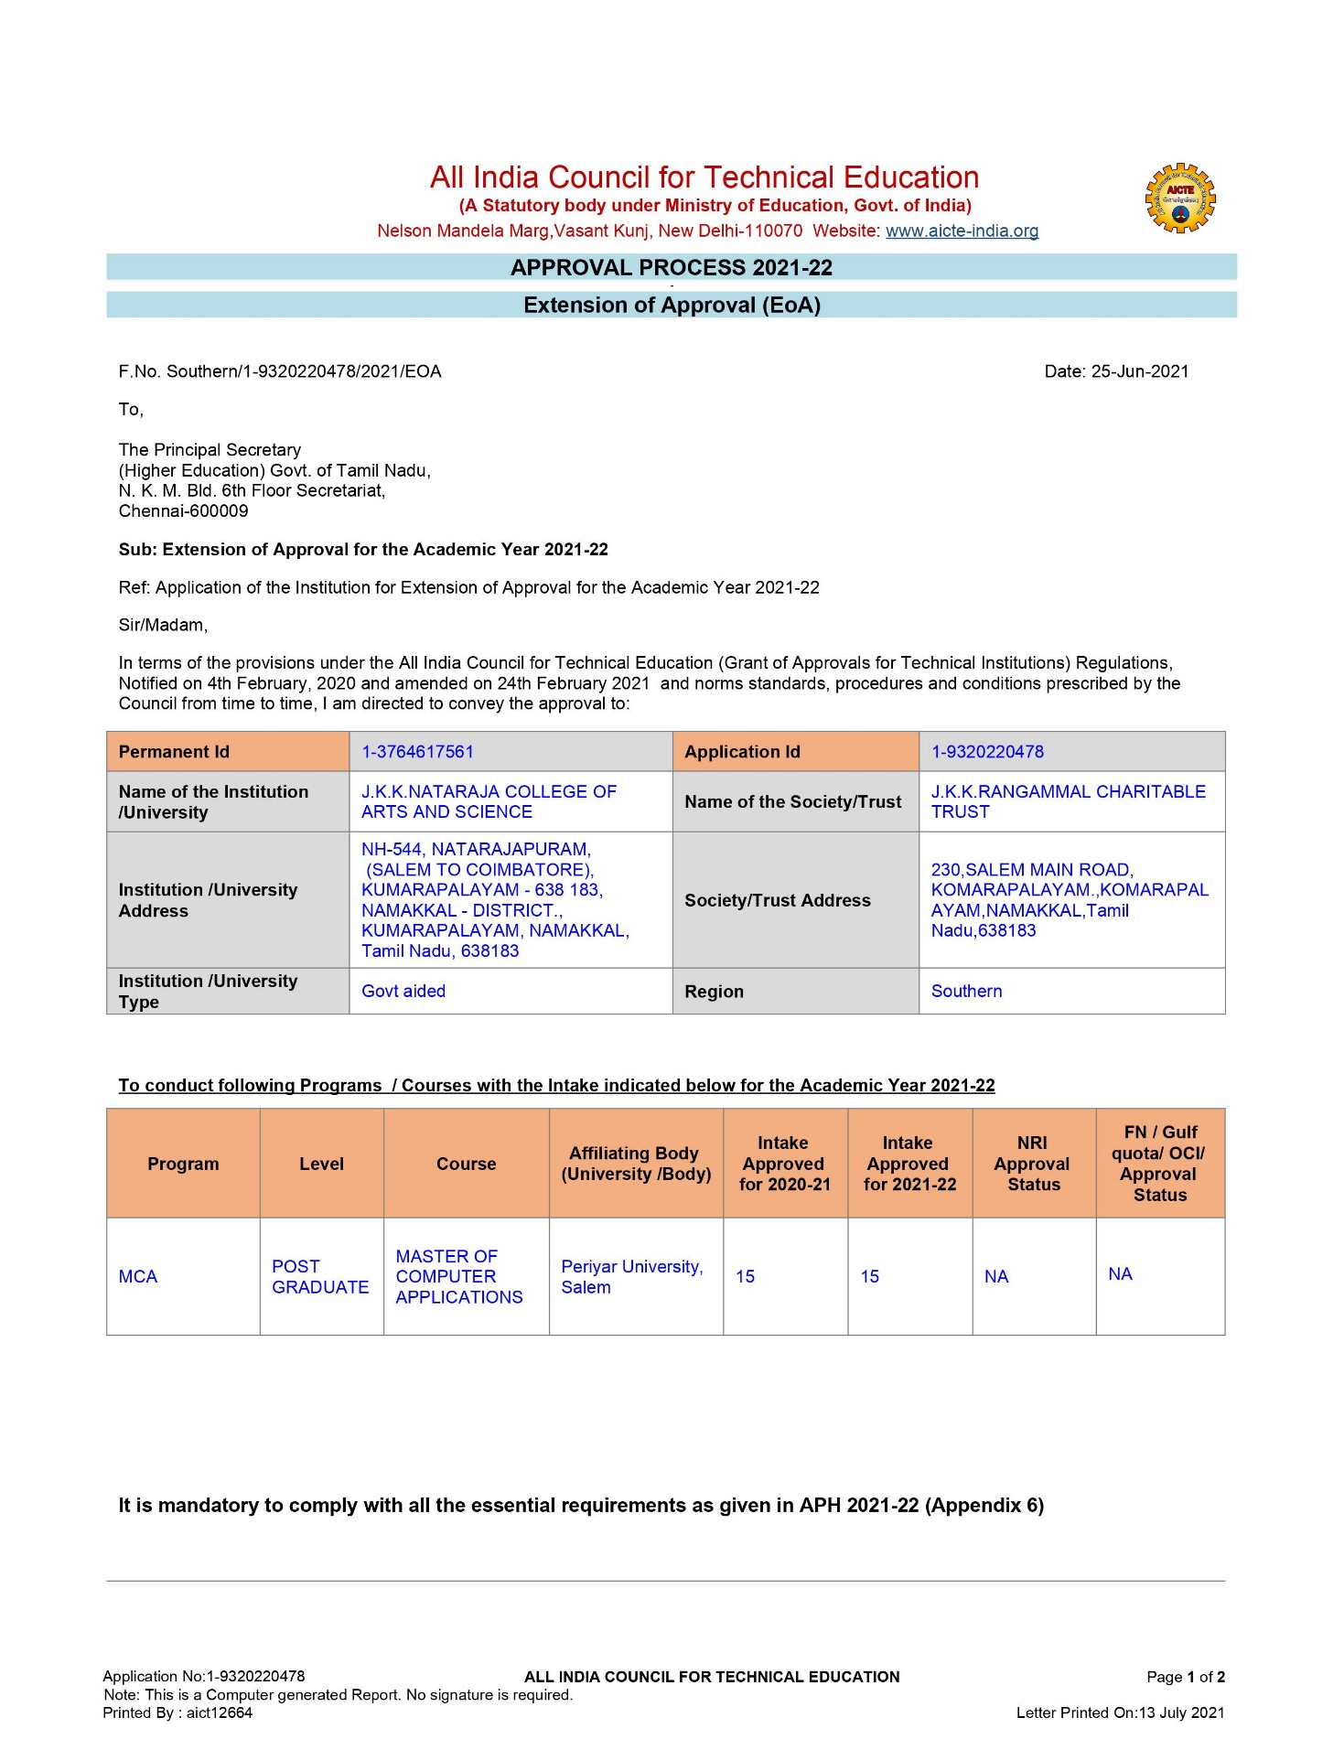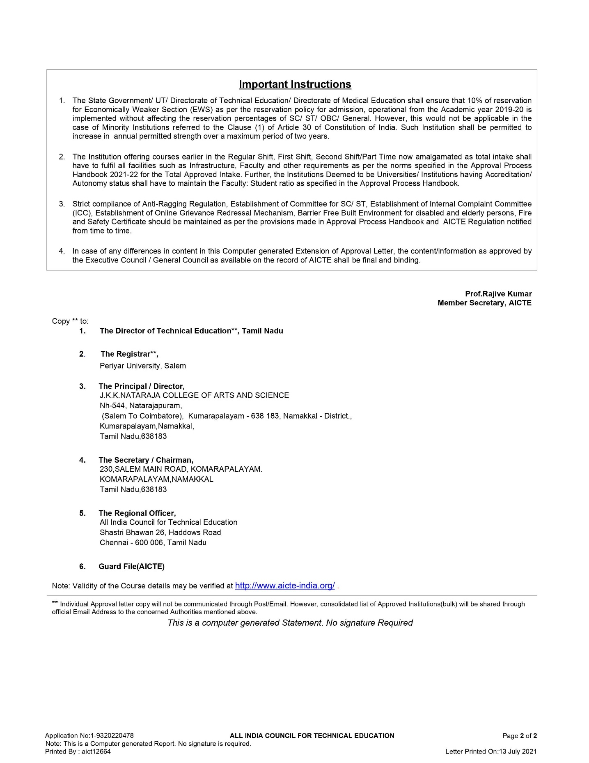

EOA Report 2022-2023

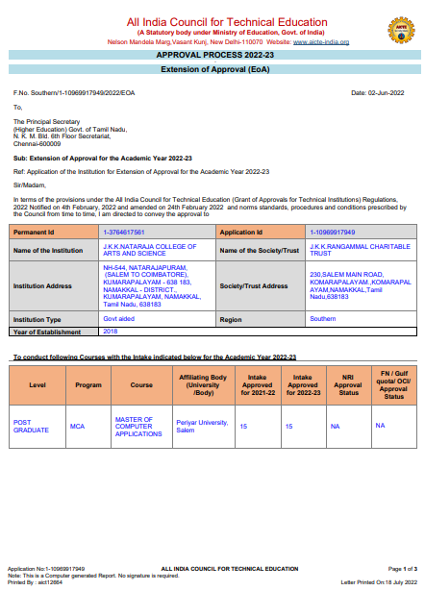
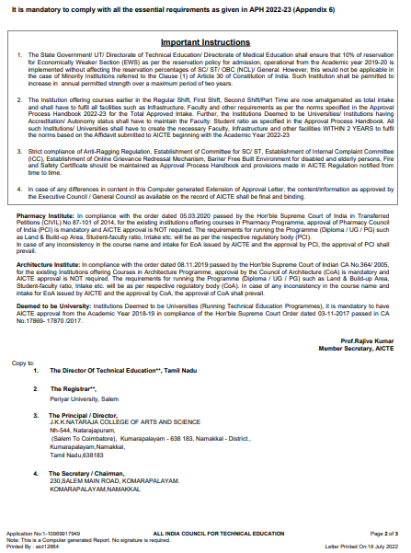
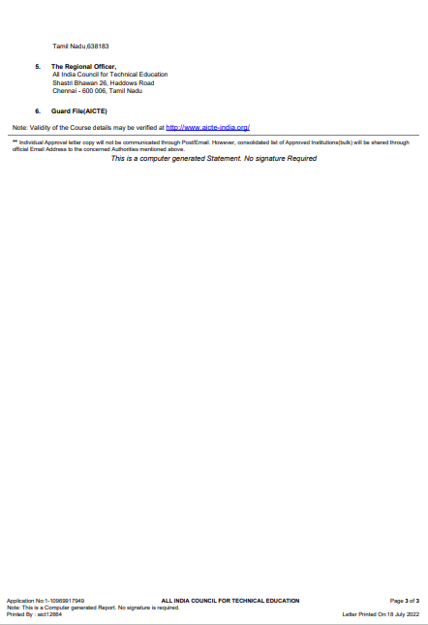

  - Accounted audited statement for the last three years : Updated in Website

Infrastructure Photos :

ENTRANCE
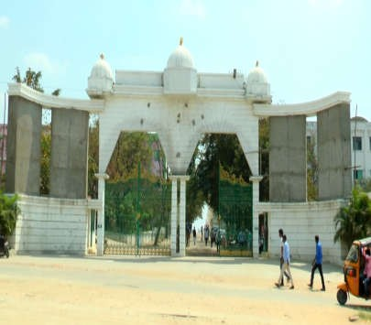
ENTRANCE BLOCK
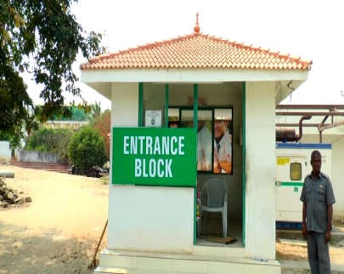
SECURITY

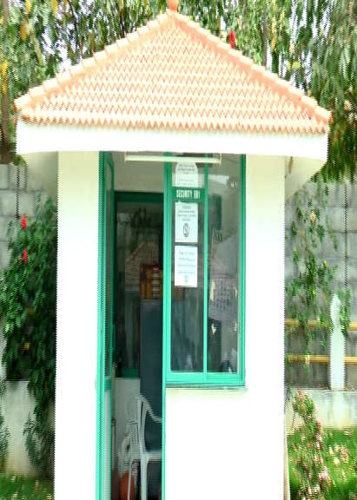

SIGN BOARD
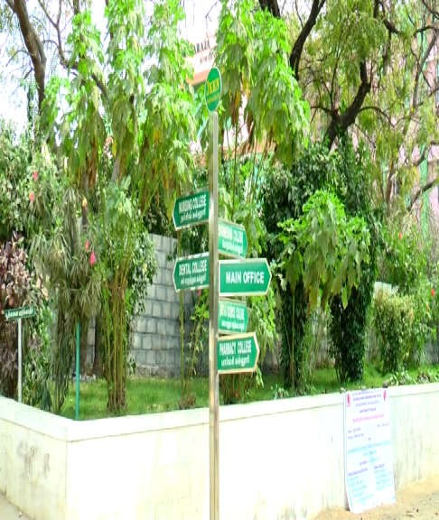
SIGN BOARD ARTS AND SCIENCE

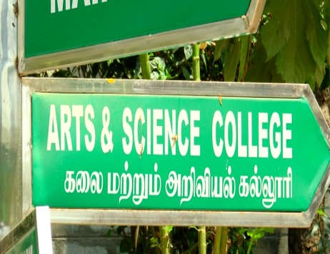
PRINCIPAL OFFICE
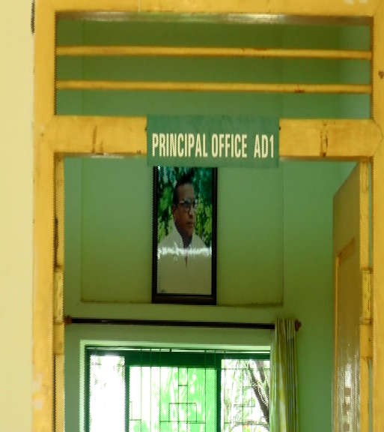

OFFICE

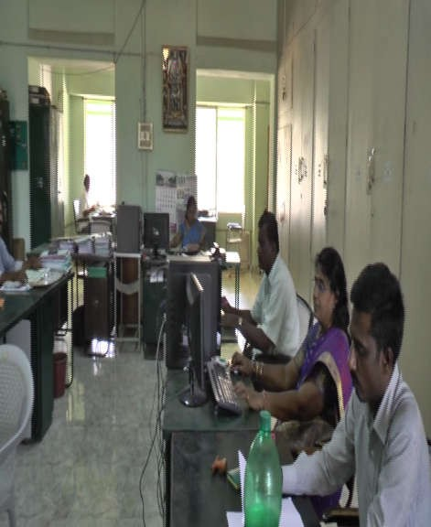

REPROGRAPHY ROOM
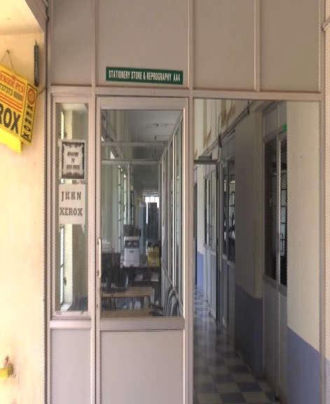

SEMINAR HALL INSIDE

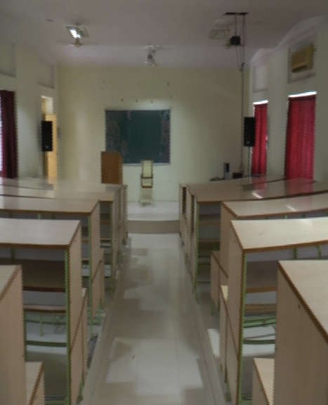

BLOCK1
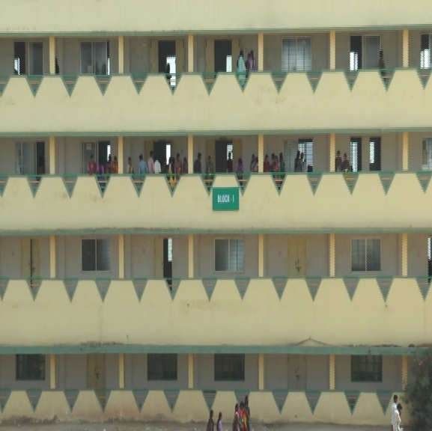

BLOCK2

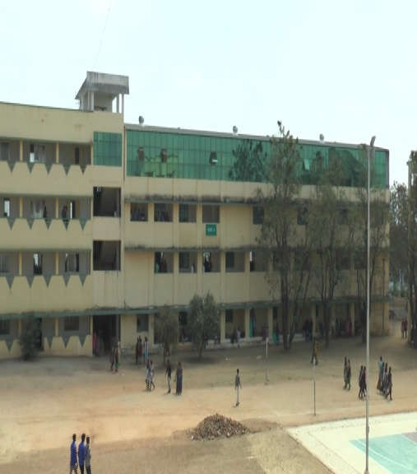

MAIN BLOCK
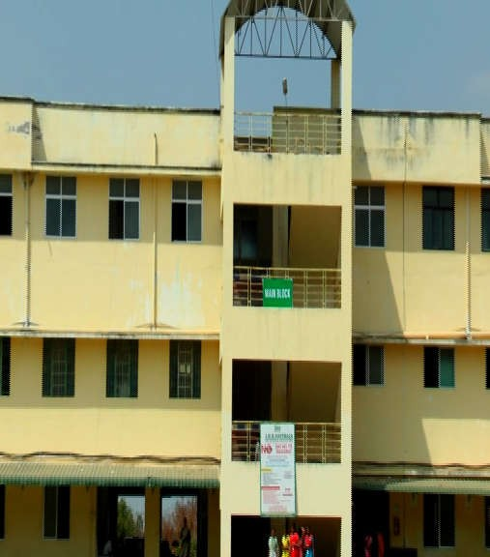

CLASS ROOM1

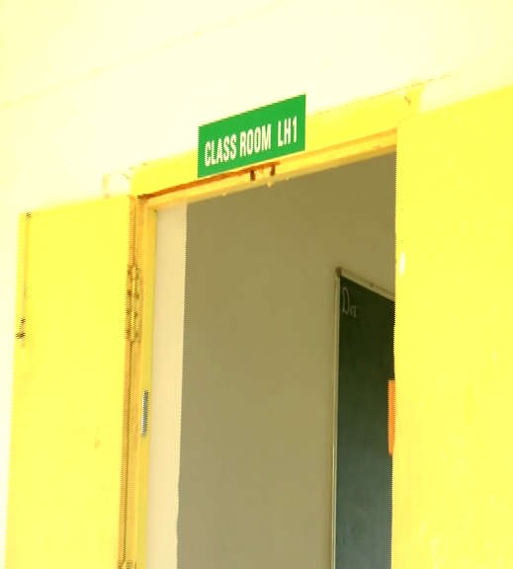
CLASS ROOM2
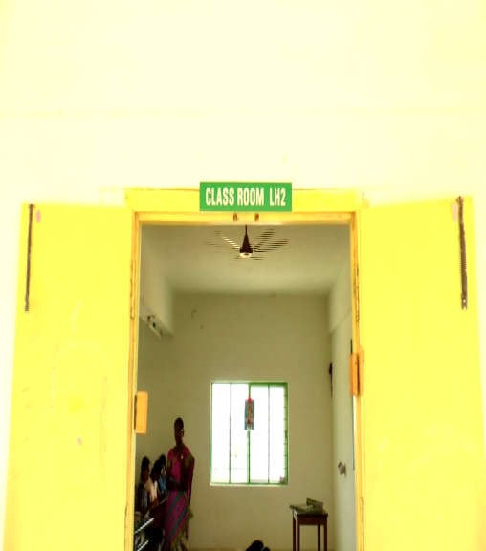

CLASS ROOM3

CLASS ROOM 3 INSIDE

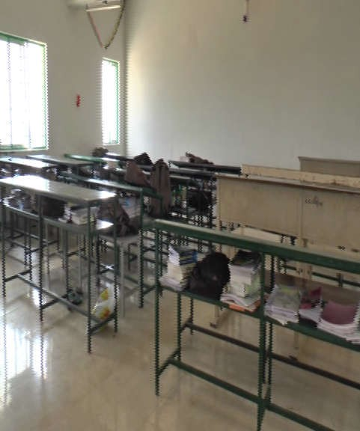

LABORATORY 1 INSIDE
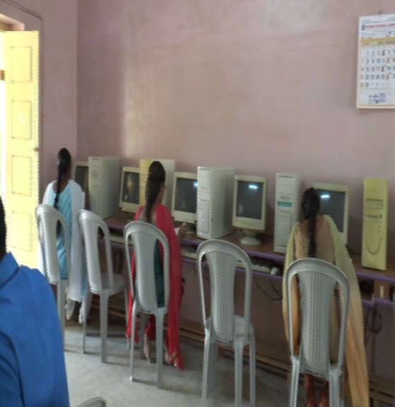

LABORATORY 2 INSIDE
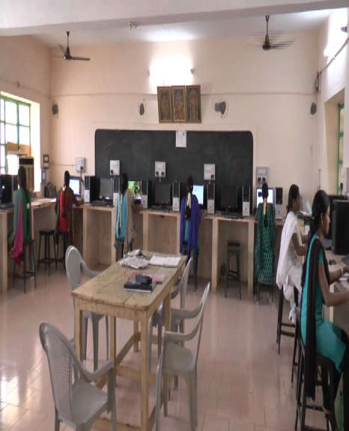

LABORATORY 3 INSIDE
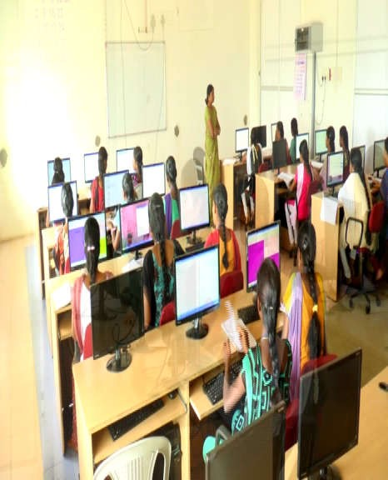

FACULTY ROOM INSIDE
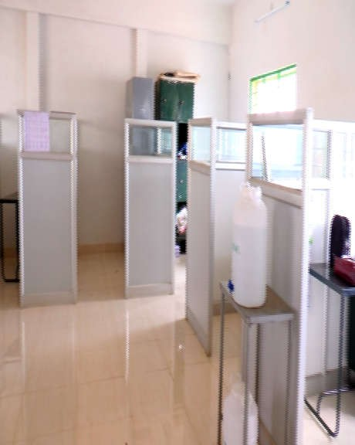

COMPUTER CENTER INSIDE

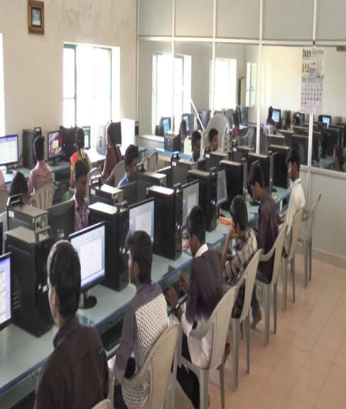

LIBRARY AND READING ROOM INSIDE
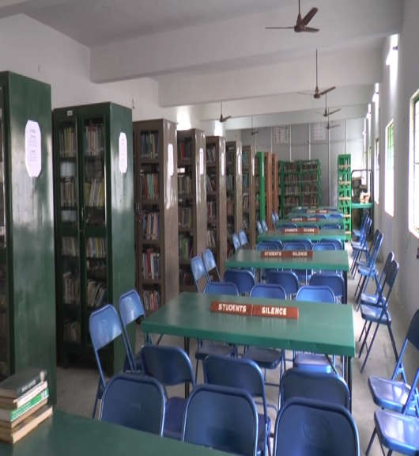

VIEW

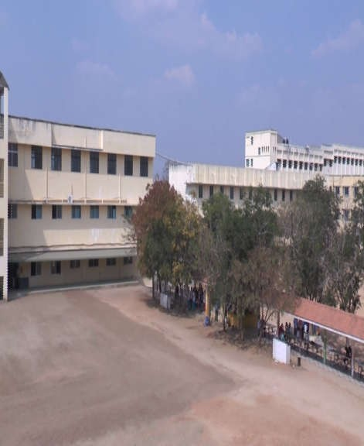

SICK ROOM
